#Include library#

import pandas as pd

import numpy as np

import matplotlib.pyplot as plt

import seaborn as sns

import sklearn

import datetime

from sklearn.metrics.pairwise import haversine_distances

from math import radians

from sklearn.model_selection import train

#For colab to upload csv file#

from google.colab import files

uploaded = files.upload()

#To read csv file#

df = pd.read_csv('NYCTaxiFares.csv')

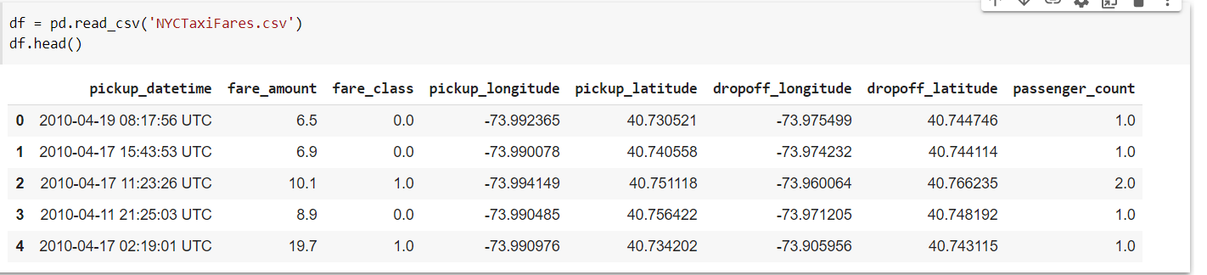

#To display first five records#

df.head()

#To display number of columns and rows#

df.shape

#To describe the data#

df.describe()

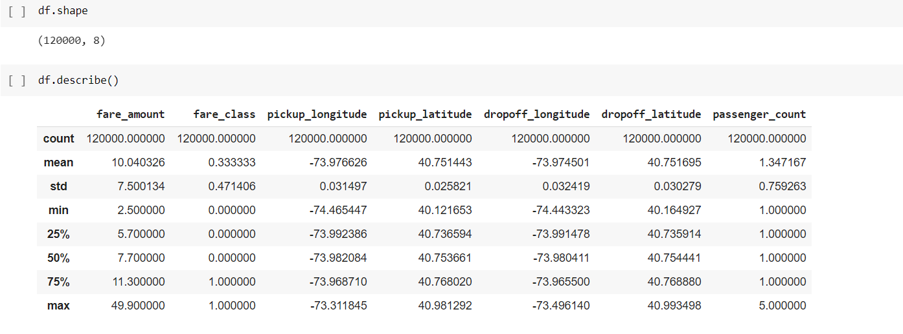

#To covert given time into Indian time#

df.pickup_datetime = pd.to_datetime(df.pickup_datetime) - datetime.timedelta(hours=4)

#Display records after change in time#

df.head()

#To find the day month year hour minute#

df['day'] = df.pickup_datetime.dt.day

df['month'] = df.pickup_datetime.dt.month

df['year'] = df.pickup_datetime.dt.year

df['hour'] = df.pickup_datetime.dt.hour

df['minute'] = df.pickup_datetime.dt.minute

df.drop('pickup_datetime', axis=1, inplace=True)

df.head()

df.columns

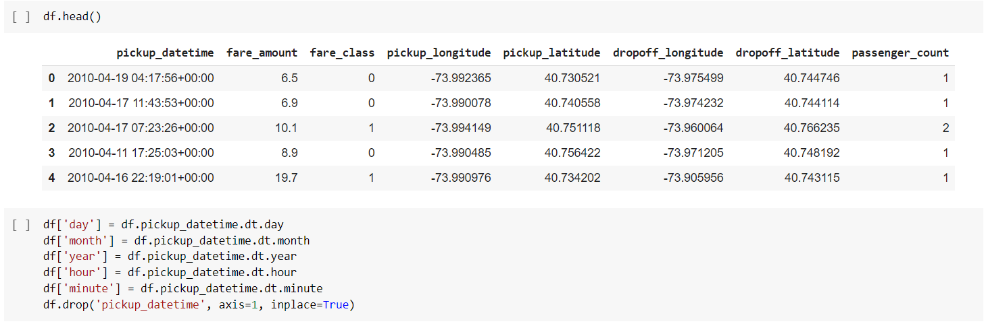

#To find data type of each column#

df.dtypes

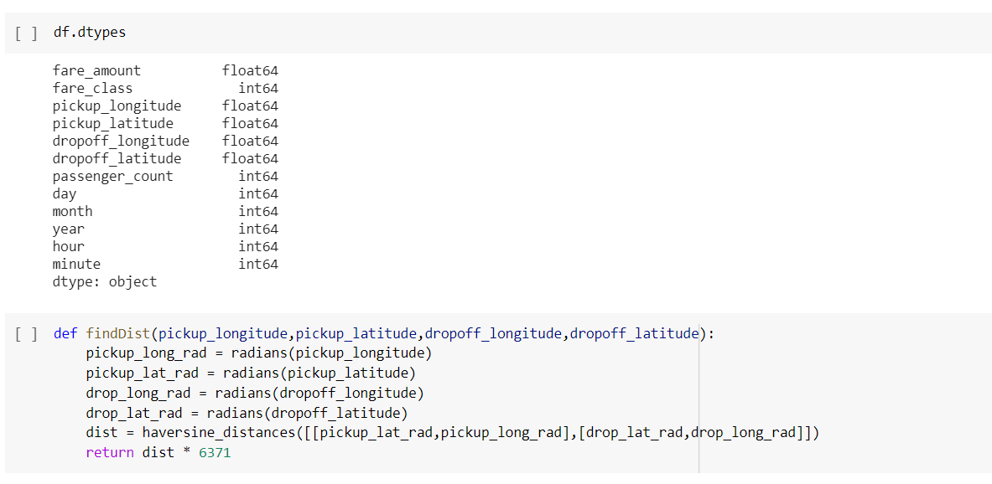

#To find the distance using given data#

def findDist(pickup_longitude,pickup_latitude,dropoff_longitude,dropoff_latitude):

    pickup_long_rad = radians(pickup_longitude)

    pickup_lat_rad = radians(pickup_latitude)

    drop_long_rad = radians(dropoff_longitude)

    drop_lat_rad = radians(dropoff_latitude)

    dist = haversine_distances([[pickup_lat_rad,pickup_long_rad],[drop_lat_rad,drop_long_rad]])

    return dist * 6371

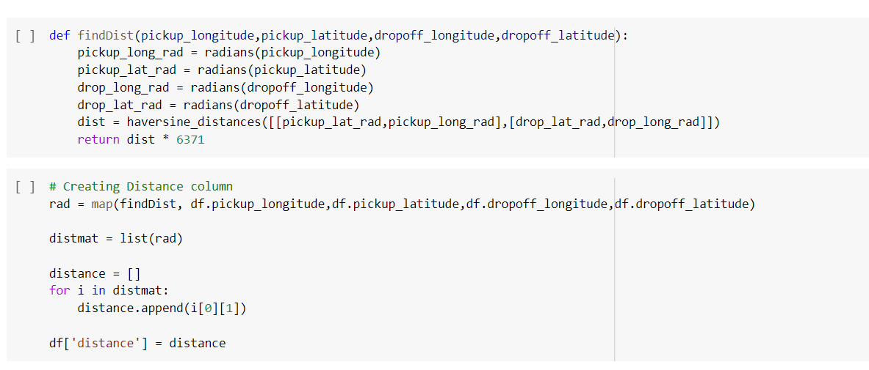

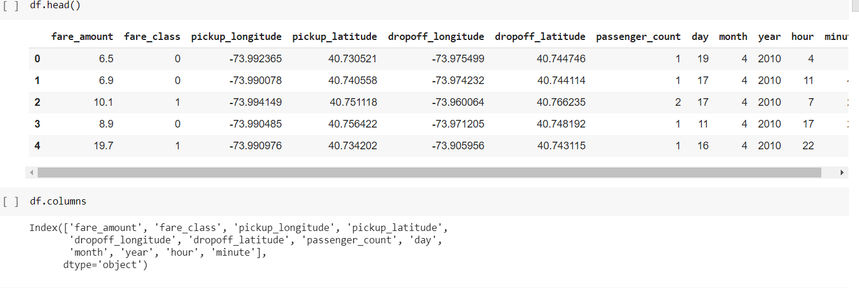

# Creating Distance column#

rad = map(findDist, df.pickup_longitude,df.pickup_latitude,df.dropoff_longitude,df.dropoff_latitude)

distmat = list(rad)

distance = []

for i in distmat:

    distance.append(i[0][1])

df['distance'] = distance

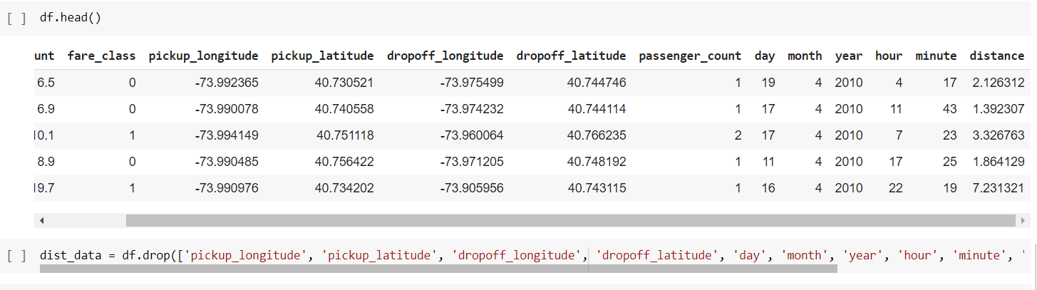

df.head()

#To drop the unwanted column#

dist_data = df.drop(['pickup_longitude', 'pickup_latitude', 'dropoff_longitude', 'dropoff_latitude', 'day', 'month', 'year', 'hour', 'minute', 'passenger_count'], axis=1)

dist_data.head()

sns.barplot(df.day.sort_index(), df.day.value_counts().sort_index())

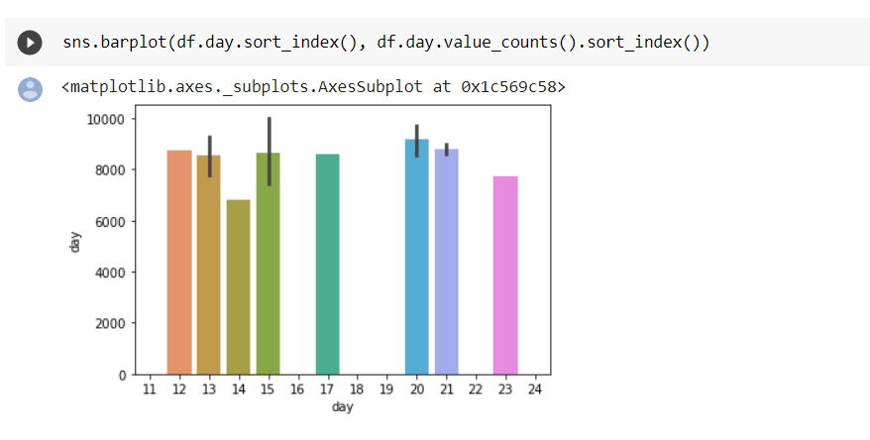

plt.plot(df.day.value_counts().sort_index())

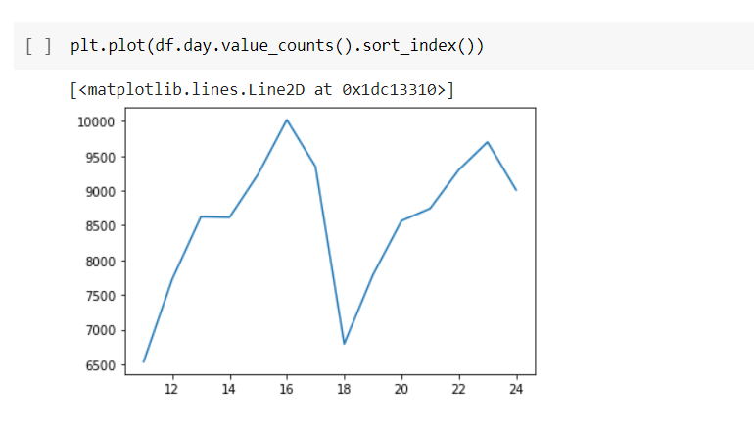

#Visualization#

sns.pairplot(dist_data, hue='fare_class')

sns.heatmap(dist_data.corr(), annot=True)

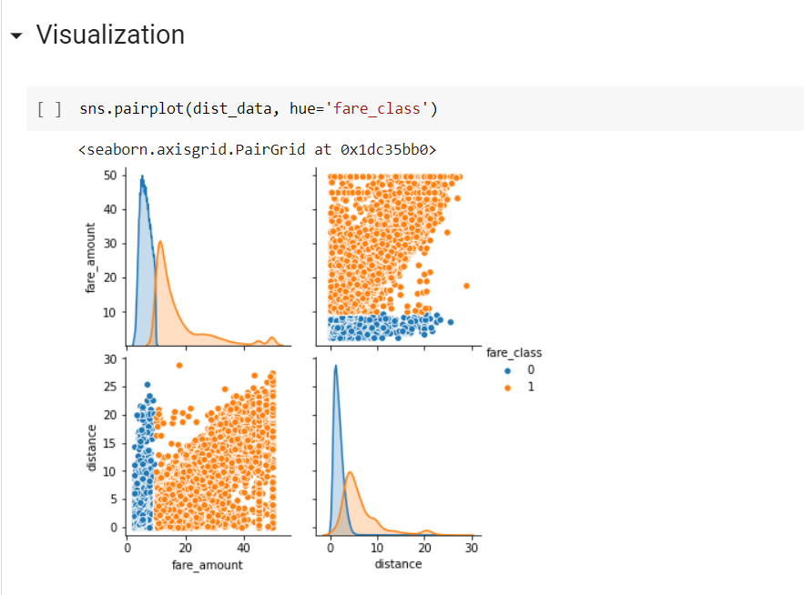

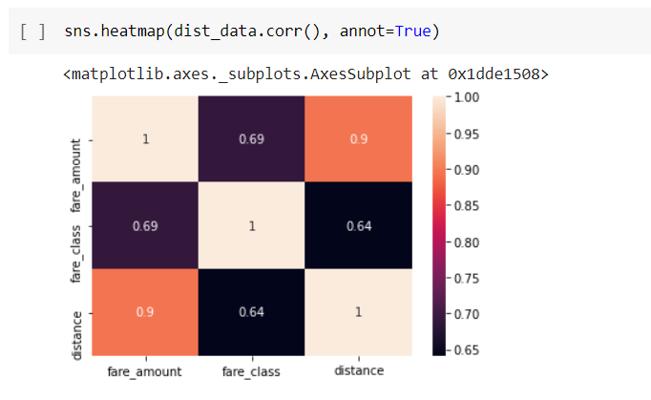

Regression

X = dist_data.drop('fare_amount', axis=1)

y = dist_data['fare_amount']

X_train,X_test,y_train,y_test = train_test_split(X,y,test_size=0.2)

from sklearn.linear_model import LinearRegression

lin_reg = LinearRegression(normalize=True, n_jobs=-1)

lin_reg.fit(X_train,y_train)

print('Score:', lin_reg.score(X_test,y_test)*100)

